1. Read an Image and Convert to Grayscale
Aim
To read an image using Python and convert it into grayscale.
Procedure
- Import OpenCV.
- Read the image.
- Convert the image from BGR to grayscale.
- Display the original and grayscale images.
Program
import cv2

img = cv2.imread(r"C:\Users\Srihari\OneDrive\Desktop\Downloads\exp12.jpg")

gray = cv2.cvtColor(img, cv2.COLOR_BGR2GRAY)

cv2.imshow("Original Image", img)
cv2.imshow("Grayscale Image", gray)

cv2.waitKey(0)
cv2.destroyAllWindows()
original image :
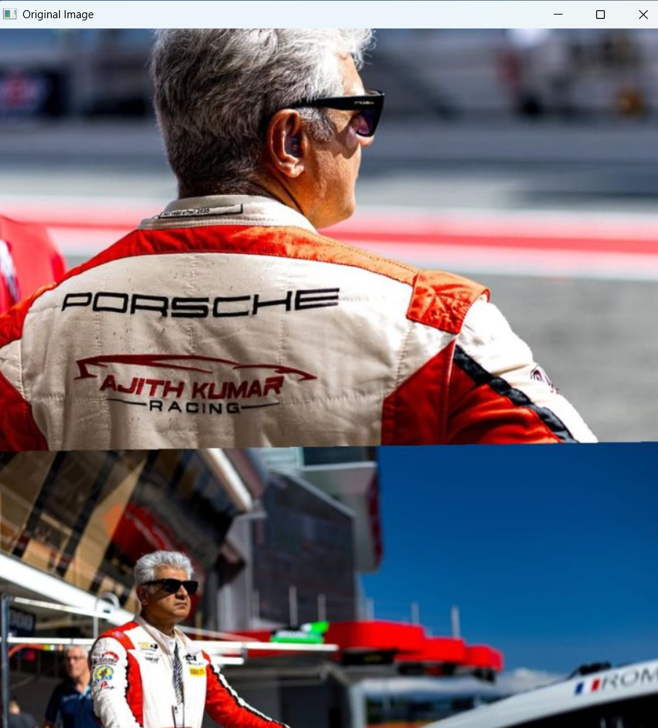
Grayscale image :
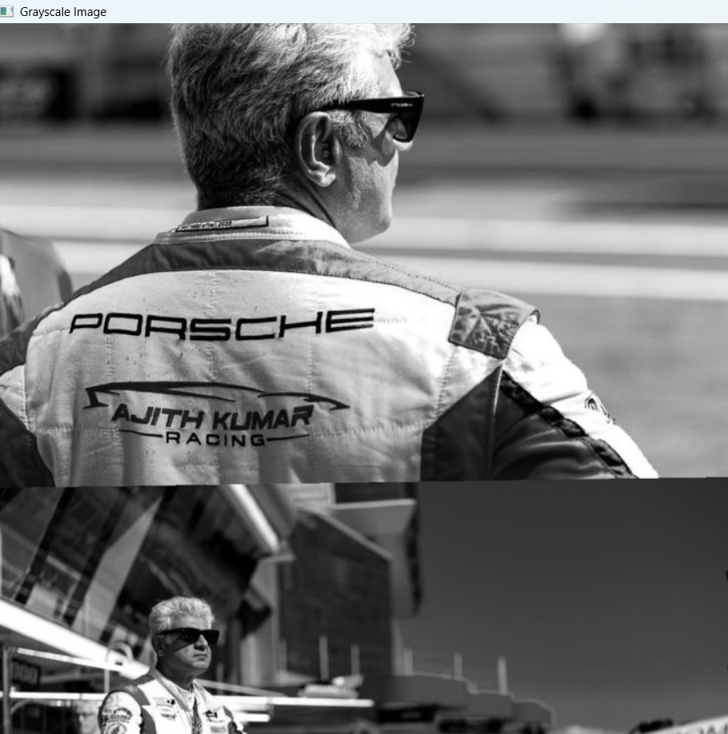

Result
The image was successfully read and converted to grayscale.

2. Gaussian Blur
Aim
To blur an image using the Gaussian Blur technique.
Procedure
- Read the image.
- Apply GaussianBlur().
- Display the original and blurred images.
Program
import cv2

img = cv2.imread(r"C:\Users\Srihari\OneDrive\Desktop\Downloads\exp12.jpg")

blur = cv2.GaussianBlur(img, (15, 15), 0)

cv2.imshow("Original Image", img)
cv2.imshow("Gaussian Blur", blur)

cv2.waitKey(0)
cv2.destroyAllWindows()
original image:

Blurred image:



Result
The image was successfully blurred using Gaussian filtering.

3. Outline Using Canny Function
Aim
To detect the outline of an image using the Canny edge detection method.
Procedure
- Read the image.
- Convert it to grayscale.
- Apply Canny edge detection.
- Display the detected edges.
Program
import cv2

img = cv2.imread(r"C:\Users\Srihari\OneDrive\Desktop\Downloads\exp12.jpg")

gray = cv2.cvtColor(img, cv2.COLOR_BGR2GRAY)

edges = cv2.Canny(gray, 100, 200)

cv2.imshow("Original Image", img)
cv2.imshow("Canny Edge", edges)

cv2.waitKey(0)
cv2.destroyAllWindows()

original image:

Canny image:

